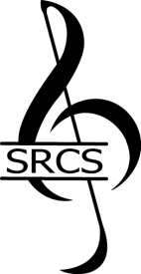
STAFFORD REGIONAL CHORAL SOCIETY
2023 Music Scholarship Application
Please complete the following application and submit with 5"x7" color photograph of yourself, the signed guidelines sheet, score and a Letter of Recommendation from your music teacher or director.
Submission deadline: January 05, 2022 Auditions held: January 7, 2022

Section I - Applicant Information

Name (First, Middle, Last): Address:

Phone: Date of Birth:
Email:

Parents' Names
Parents' Email:

Name of School:

School Phone:
Graduation Date:

Instrument/Vocal Part:
Title of Audition Piece: Composer:
Arranger:
Note: You must arrange for your own accompanist, if you require one.

Section II - Musical Experience and Activities (to include honors and/or awards)
Briefly describe your experience and activities here.

Section III - Academic Plans

What College/University Do You Plan to Attend?

Have You Been Accepted? Yes No Don't Know Yet
Do you plan to major in music? Yes No Don’t’ know yet

If not majoring in music, how do you plan to continue your study of music?
________________________________________________________________________________________

Note: Your application is not complete until you submit a 5x7-inch color photograph of yourself, Signed guidelines sheet, score and one Letter of Recommendation Questions? Contact us at . StaffordRegionalChoralSociety@yahoo.com

