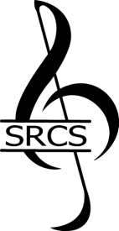
STAFFORD REGIONAL CHORAL SOCIETY
2020 Music Scholarship Application
Thank you for taking time to share your thoughts and comments about this applicant. Your recommendation will be invaluable to our efforts in choosing a scholarship recipient.
Submission deadline: January 11, 2020 Auditions will be held: January 18, 2020

Applicant Name:

Your Name:

Phone:
Email:

How do you know the applicant? __________________________________________________________________________
Please tell us about the applicant.

Please email your completed recommendation to: info@staffordchoral.org
Thank you!

