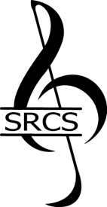
STAFFORD REGIONAL CHORAL SOCIETY
2022 Music Scholarship Recommendation
Thank you for taking time to share your thoughts and comments about this applicant. Your recommendation will be invaluable to our efforts in choosing a scholarship recipient.
Submission deadline: January 5, 2022 Auditions will be held: January 9, 2022

Applicant Name:

Your Name:

Phone:
Email:

How do you know the applicant? __________________________________________________________________________
Please tell us about the applicant.

Please email your completed recommendation to: StaffordRegionalChoralSociety@yahoo.com
Thank you!

